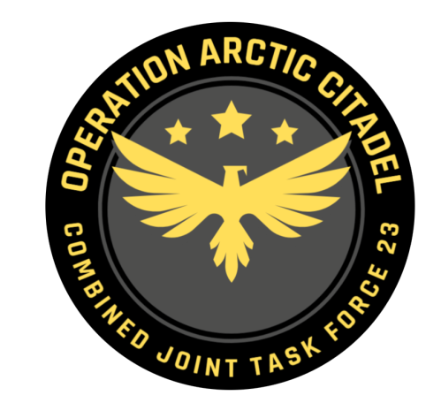

Joint Force Commander CJTF-23

DIRECTION AND GUIDANCE

D2

This document covers the friendly situation from D1 and provides CJTF-23 guidance to the entire force for D2.

**Reference CombatFlite**: <https://132nd-vwing.github.io/OPAC-Brief/SITUATION/Friendly%20Situation.cf>

# SITUATION

## General situation

Road to war according to introduction brief: [Operation Arctic Citadel Introduction Brief](https://132nd-vwing.github.io/OPAC-Brief/SITUATION/132nd%20OP%20ARCTIC%20CITADEL%20Introduction%20Brief.pdf)

D0: September 20th 2011:

JFACC[1] initiated intelligence gathering related to the situation, and completed phase 1 (Deployment) into theater. LCC[2] started deployment of IV Corps into Finland and are continuing force buildup.

D1: September 21st 2011:

JFACC initiated deterrence of Notian forces, but deterrence was unsuccessful. SEAD/DEAD conducted toward high-end SAMs in 1st and 3rd Corps area, while conducting attacks at HQs as part of slowing down enemy advance.

LCC moved into contact with Notian forces at the end of D1 at three locations.

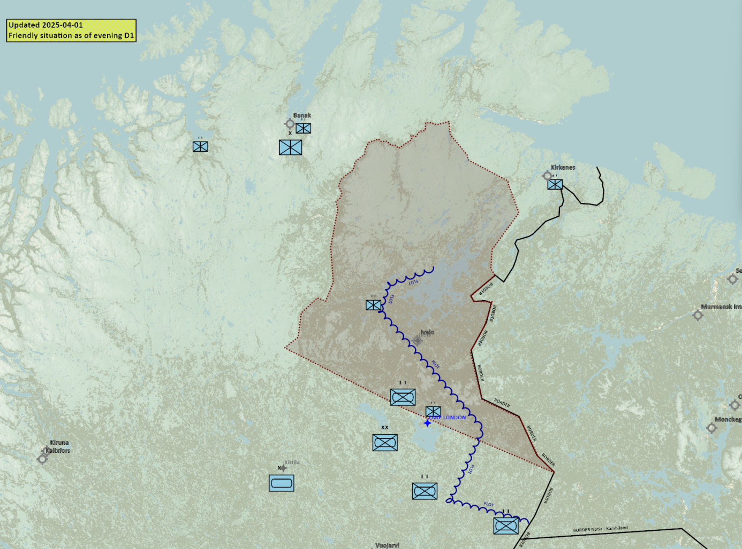

## Friendly situation

### Land Component Command (LCC)

#### IV Corps

##### 55th Armor Division (Abrahams and Challenger 2 tanks)

Currently in reserve located around Kittila.

##### 56th Mechanized Division (M2A2 Bradley, LAV-25 and Humwee’s)

Lead elements of the 56th Division have established contact with the enemy in three locations:

BN 1: South of Ivalo

BN 2: West of Lokka

BN 3: Northwest of the border between Notia, Kambiland and Finland

#### Finnish local forces

* The Finnish 33rd Brigade (M-113s)
* First BN – In heavy fighting with enemy forces. Withdrawn to Inari.
* Second BN- located IVO FARP LONDON.

#### Norwegian local forces

* The Norwegian 44th Brigade (M-113s, Leopard and Bradley)
* First BN (Bradley IFV) – Located IVO Kirkenes
* Second BN (M113 APC) – Located IVO Banak
* Third BN (Leopard MBT – Located IVO Alta

### Maritime Component Command (MCC)

* CSG Continues workup SOUTH of Bodø.

### Special Operations Component Command (SOCC)

* SOF teams are standing by to support with reconnaissance as required.
* SOF teams are also on standby to conduct counter terrorism missions and counter insurgency operations.

# Reported Battle Damage Assessment

## IV Corps Northern Sector

* 6x Main Battle Tanks

## Finnish local forces.

* 6x BMP-3

## Norwegian local forces.

* NSTR

# Logistical situation

Available ordnance: <https://132nd-vwing.github.io/OPAC-Brief/MISSION%20INFORMATION/OPAC%20Ordnance.pdf>

# Direction and Guidance

## LCC:

* Defend against Notian invasion and be prepared to retake land in claimed Notian territory.

## MCC:

* Continue force buildup and move Carrier Strike Group into the area by the end of D2.

## JFACC:

* Apportionment[3]
  + Per JFACC priorities
* JFACC are now in phase 3a DEFEND.
* Priority of effort is to establish air superiority
* Recommend to JFC changes in diplomatic status for any country during target meeting.
* Request to JFC ordnance if additional ordnance are needed during the target meeting.
* Recommend to JFC location of Carrier Strike Group during target meeting.

## VIS:

* Support JFACC with planning and execution of campaign.
  + Be prepared to support JFACC with phase 3a and 3b planning
* Recommend to JFC changes in diplomatic status for any country during target meeting.

## Diplomatic situation

* Notia is declared as adversary
* Kambiland is declared as neutral
* Xilong is declared as neutral
* DUSS is declared as neutral
* The Iron Resolve is declared as enemy
* The Dawn’s Vengeance is declared as adversary

Only units declared as enemy can and should be engaged by CJTF forces.

**Definitions:**

Enemy: is actively opposed or hostile to CJTF and friendly forces.

Adversary: opponent in a contest, conflict, or dispute toward CJTF and friendly forces.

Neutral: not supporting or helping either side in a conflict, disagreement, etc.; impartial.

1. Joint Force Air Component Commander – Commander of all air forces (player volunteers)
2. Land Component Commander – Commander of all land forces
3. Air apportionment is the determination and assignment of the total expected effort by percentage and/or priority that should be devoted to the various air operations and/or geographic areas for a given period of time.